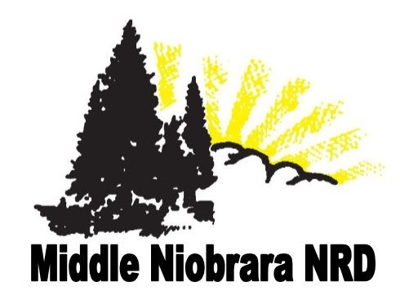

**Issue**

Fall

***in this issue >>>***

*Long Pine Creek Watershed*

*2019 Spring Static Water Levels*

*Woody Biomass Utilization*

*Ponderosa Pine Restoration*

*Tree Program 2019*

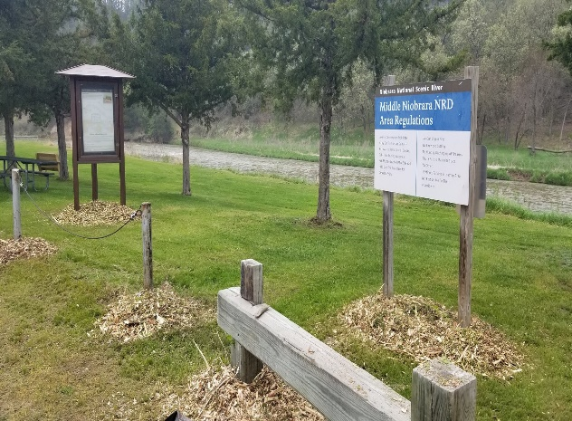

### **Conservation Tree Planting**

* Time to start thinking about what trees you want for Spring 2020

***Staff:***

### **Woody Biomass Utilization**

* Wood Chip Creation
* Wood Chip Applications
* Composting

Mike Murphy

General Manager

Zachery Peterson

Assistant/Office Manager

Tim Storm

Water Programs Supervisor Dana Krueger

Natural Resources Supervisor

Chandler Schmidt

Watershed Coordinator

Kyle Temple

Natural Resources Technician

Wendy Tillman

Administrative Assistant

### **Water Quality Cost Share**

* **Sign up Nov 1st - Dec 31st**
* Surge Values
* Low Pressure Nozzles
* Converting Siphon Tubes to Gated Pipes 50% up to $2,500
* Soil Moisture Sensors 50% up to $1,000

### **NSWCP Cost Share**

* **1st Sign up deadline was due 6/21/19**
* Trees 50% up to $4,000
* Planned Grazing 60% up to $5,000
* Miscellaneous practices 60% up to $5,000
* **2019-2020 Cost share funds are all allocated**
* Reminder for 2020-21:Signup is in MAY!!

*.*

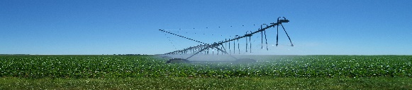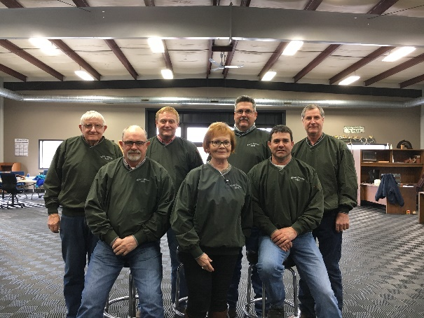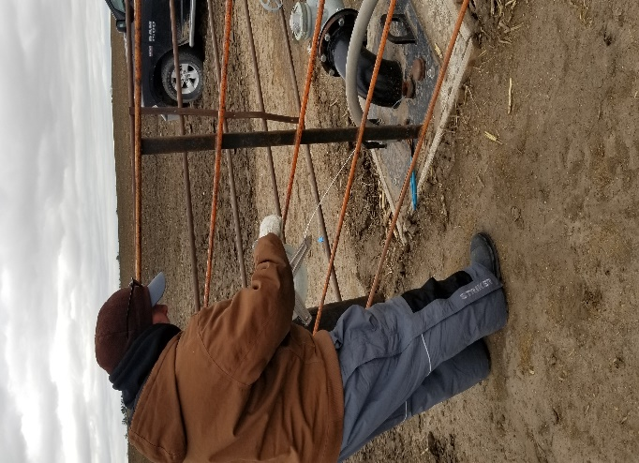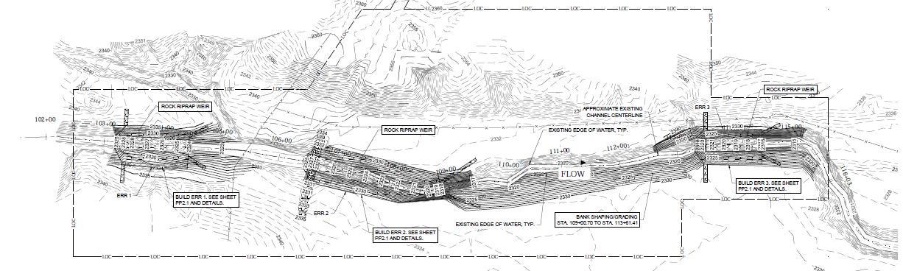

* A total of 196 wells were measured for static water levels in the spring of 2019. 179 wells showed an increase from the spring of 2018, while 17 wells showed a decrease.
* The largest increase measured was 7.13 ft Northeast of Long Pine and the largest decrease measured was -2.35 feet South of Cody. The average for the District was a 1.48 feet increase.

Brown Cherry Keya Paha Rock

Largest Increase 5.28 ft. 3.59 ft. 5.40 ft. 7.13 ft.

Largest Decrease -0.32 ft. -2.35 ft.

Average 1.50 ft. 0.67 ft. 2.97 ft. 3.45 ft.

*2019 Spring Static Water Levels*

The MNNRD and JEO Consultants are addressing threats to water quality, streambed channel, aquatic habitat and infrastructure within the Long Pine Creek Watershed (LPCW) by implementing Best Management Practices (BMP) within the LPCW and an In-Stream Structure on Sand Draw Creek. The watershed, approximately 332,000 acres primarily in Brown County, is mostly irrigated farming and rangeland within the Ainsworth and Long Pine communities. Grants from Nebraska Department of Environmental Quality and Nebraska Environmental Trust are helping fund the BMP’s and construction of the structure on Sand Draw Creek. An application for an NRCS Watershed Work Plan (EA) in the LPCW through the WFPO Program was submitted and approved to obtain additional funding. The hiring of a consultant and the two-year planning phase will begin shortly looking at resource management concerns through watershed protection, water agricultural management, and public fish and wildlife.

*Long Pine Creek Watershed*



Back Row: Dean Jochem, Greg Wilke (Chairman), Justin Hammond, & Len Danielski (Vice-Chairman)

Front Row: Marty Graff, Cherryl Lovejoy (Secretary/Treasurer), & Mark Johnson

*Board of Directors*



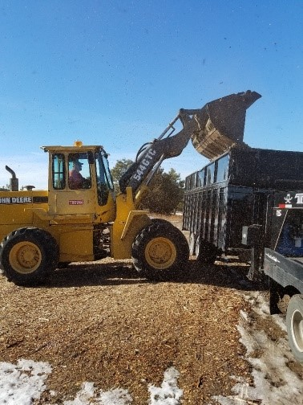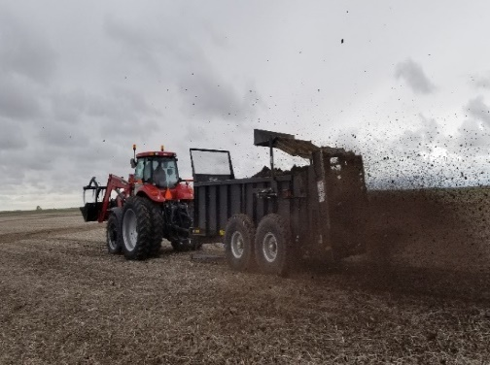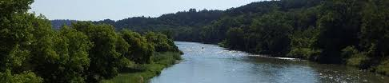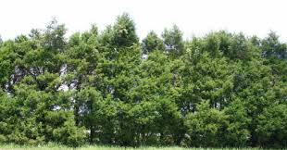

**319: Long Pine Creek Watershed Phase I**

- $97,500

- Nonpoint Source Water Quality Grant

**Expansion of Water Quality & Quantity Monitoring Sites**

$111,250

**Efficiency in Irrigation “Know your Flow”**

$3,000

We are excited to see and document the changes in soil health and productivity of these plots.

The MNNRD was also awarded two grants to purchase equipment for use with the woody biomass utilization program. The Nebraska Recycling Council, funded through the Nebraska Environmental Trust (NET), awarded a grant to purchase a used John Deere 544GTC Payloader. Additionally, NET awarded a grant to allow the purchase of a Case 210 CVT tractor to operate the districts compost turner and manure spreader. Both pieces of equipment will allow them MNNRD to expand its woody biomass program into the composting realm. Composting is scheduled to begin this fall with a cooperating producer. Three trials will be implemented utilizing wood chips and manure in different mixture ratios. Evaluation of the success of each trial will be made for future composting efforts.

The MNNRD in conjunction with the University of Nebraska and 5 other NRD’s have initiated the first year of the Waste to Worth research project. This project will study the agronomic, economic, environmental and soil health benefits from applications of wood chip and animal manure to research plots on cooperating producers’ fields. The MNNRD produced and hauled cedar chips to 2 of the 6 research sites and spread the manure and wood chips on plots located within the MNNRD district.

***Woody Biomass Utilization***



**John Deere 544 GTC Payloader**

$20,000

**Woody Biomass Utilization Compost Tractor**

$192,000

**Long Pine Creek Watershed Phase I**

$250,000

**Long Pine Creek Watershed Phase II**

$451,530

The Middle Niobrara NRD and the Nebraska Forest Service are again offering cost-share assistance in 2020 to plant Ponderosa Pine seedlings in areas burned in past wildfires. If you are interested, and willing to plant at least 1,200 trees on your property, the cost-share would cover 90% of the costs for the seedling and the planting. Anyone is available to sign up, however, we would like to give new cooperators first chance at the available seedling pool. To learn more about this project please contact the MNNRD office @ 402-376-3241, or Rich Woollen with the NE. Forest Service @ 308-728-3221.

**PONDEROSA PINE REFORESTATION TREES AVAILBLE AGAIN IN 2020**

***Grants:***

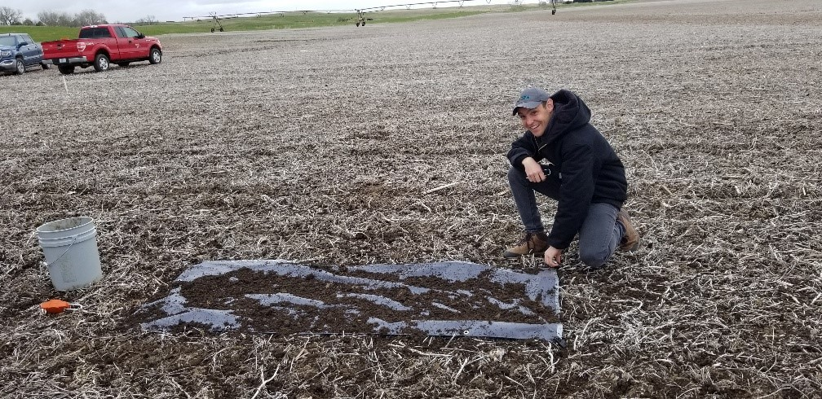

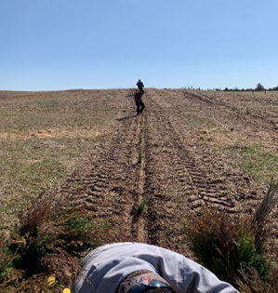

***Tree Program 2019***

*Finding An Agent That’s Right For You*

303 East Highway 20

Valentine, NE 69201

MNNRD

To encourage tree planting, the MNNRD provides low-cost tree and shrub seedlings to landowners. Cost share assistance, project design, weed barrier, drip irrigation and planting services are all available. Trees are planted throughout the district for protecting homesteads and livestock from the sun and wind, reducing soil erosion and atmospheric carbon dioxide, flood control, wildlife habitat, aesthetic value, noise reduction and as a “living snow fence”. This year 11,762 trees were planted, and 55,560 feet of fabric weed barrier was installed by the MNNRD crew. In 2019 there was a total of 29,078 hand plant trees sold.

Contact us at **402-376-3241** www.mnnrd.org